# MAT 230 Module Eight Homework

**General:**

* Before beginning this homework, be sure to read the textbook sections and the material in Module Eight.
* Type your solutions into this document and be sure to show all steps for arriving at your solution. Just giving a final number may not receive full credit.
* You may copy and paste mathematical symbols from the statements of the questions into your solution. This document was created using the Arial Unicode font.
* These homework problems are proprietary to SNHU COCE. They may not be posted on any non-SNHU website.
* The Institutional Release Statement in the course shell gives details about SNHU’s use of systems that compare student submissions to a database of online, SNHU, and other universities’ documents.

1. Draw a picture of the graph G = (V, E, ) where V = {t, u, v, w, z}, E = {e1, e2, e3, e4, e5}, and (e1) = {v, w}, (e2) = {t, u}, (e3) = {t, v}, (e4) = {u, w}, (e5) = {t, w}. You may use (copy/paste/move/resize/etc.) the images below to create your graph.

This problem is similar to Examples 1 and 2 and to Exercises 7 and 8 in Section 8.1 of your SNHU MAT230 textbook.

1. Consider Kn, the complete graph on n vertices. Explain how you calculated your answers.
   1. What is the degree of each vertex?
   2. How many edges does Kn have?

This problem is similar to Example 6 and to Exercises 13 and 14 in Section 8.1 of your SNHU MAT230 textbook.

1. The degree of each vertex will be n – 1
2. Each vertex will have n – 1 edges, so $K_{n}$ will have $n*(n-1)$ edges.
3. Does the following graph have an Euler circuit, an Euler path, both, or neither? Give reasons for your decision.

This problem is similar to Examples 4 and 5 and to Exercises 1–8 in Section 8.2 of your SNHU MAT230 textbook.

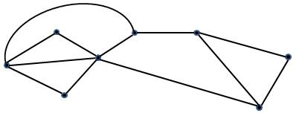

Not a Euler circuit because there are vertices of odd degrees.

Not a Euler path because there are more than 2 vertices of odd degrees.

1. Does the following graph have an Euler circuit, an Euler path, both, or neither? Give reasons for your decision.

This problem is similar to Examples 4 and 5 and to Exercises 1–8 in Section 8.2 of your SNHU MAT230 textbook.

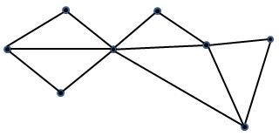

Not a Euler circuit because there are vertices of odd degrees.

A Euler path because there are exactly 2 vertices of odd degrees.

1. Use Fleury’s algorithm to produce an Euler circuit for the following graph. Start at A and label the edges in the order that you add them. Below are images you can use to number the graph.

This problem is similar to Example 6 and to Exercises 11 and 12 in Section 8.2 of your SNHU MAT230 textbook.

